Access control system, a simple version, there is no password, just identify the card number, according to determine whether the card number is correct, to judge the opening does not open the door.

Experimental procedure:
The card's number is :
93D3458C89
set the new card password, and can modify the data of the Sector: 1OK!
Read from the card ,the data is :
841011101033266111000000000
- The routine 32.RFID module experiment to burn the board inside。
The following is the serial data read:
The card's number is :
93D3458C89
set the new card password, and can modify the data of the Sector: 1OK!
Read from the card ,the data is :
841011101033266111000000000

Write down the 93D3458C89; then it is the key.
unsigned char Key_Test[5]={0x93,0xd3,0x45,0x8c,0x89};//Key password (that is, the card number)
As long as the order change, the value of the inside, on the OK

For example, I have a card number is：53 ,8 ,3F ,AA ,CE;
Andthe unsignedcharKey_Test[5]={0x93,0xd3,0x45,0x8c,0x89};
Change unsigned char Key_Test[5]={0x53,0x08,0x3F,0xAA,0xCE};
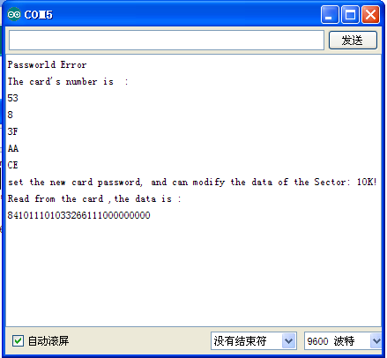

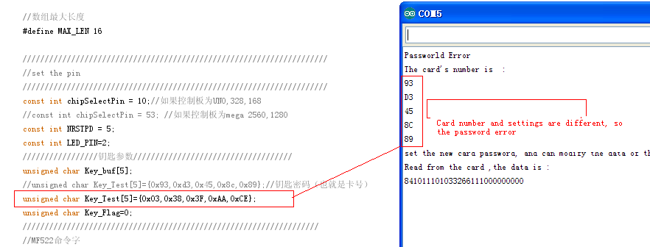

The following is the correct password
